Industry Representatives/Company Name Mt. SAC Faculty, Deans, and Staff
.
Joe Denny | Gerry Herder
Jonathan Hymer | Patrick Mallon
Ken Miller | Sam Agdasi
Jim Uranga | Sarah Plesetz
Steve Harsany | Dave Vredenburg
Eddie Lee

Item | Discussion |  |  | Outcome/Action Needed
Welcome and Introductions  (Dept Chair) | Introductions of each advisor.
Division Dean/Associate Dean | Purpose of Advisory discussion. |  |  | Sam and Sarah were having trouble with accessing their microphone
Approval of Minutes from last year | We will be sending out this year’s minutes in an email in the following week for approval. |  |  | Last year’s minutes (2019) were approved over email last year.
Advisory-Driven Program Improvements to date | Discussion of Advisory Driven Program Improvements from previous years.  - Field Service Fundamentals Course  - Customer Service Course  - Changes to Curriculum  - Added CNET 56 to Communications Cert  - Virtualization in CNET program  - Inclusion of Many Topics in Courses  - Reading Industrial Ladder Diagrams  - Extra Labs, Testing and Powerpoints  - Equipment Purchases  - Student Worker Approvals  - Industry Relationships  Curriculum Modifications:  Discussed if creating an A.S. degree in Electronics Engineering Technology would be useful for gainful employment.  Discussion if a change to our approach to certificates would make sense from an Industry point of view. Rather than our current 6 electronic certificates and 2 cnet certificates, the following changes were proposed:  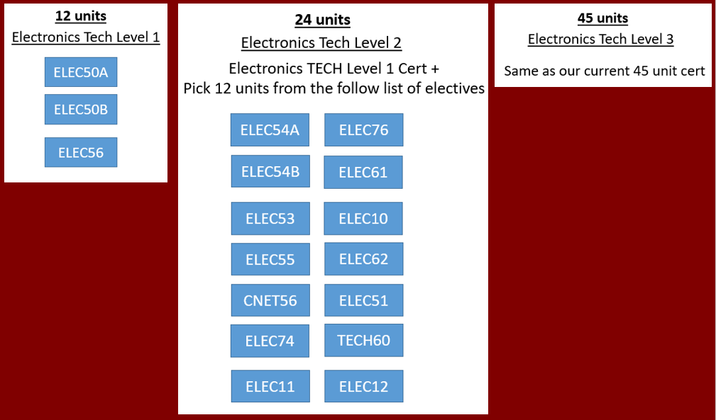  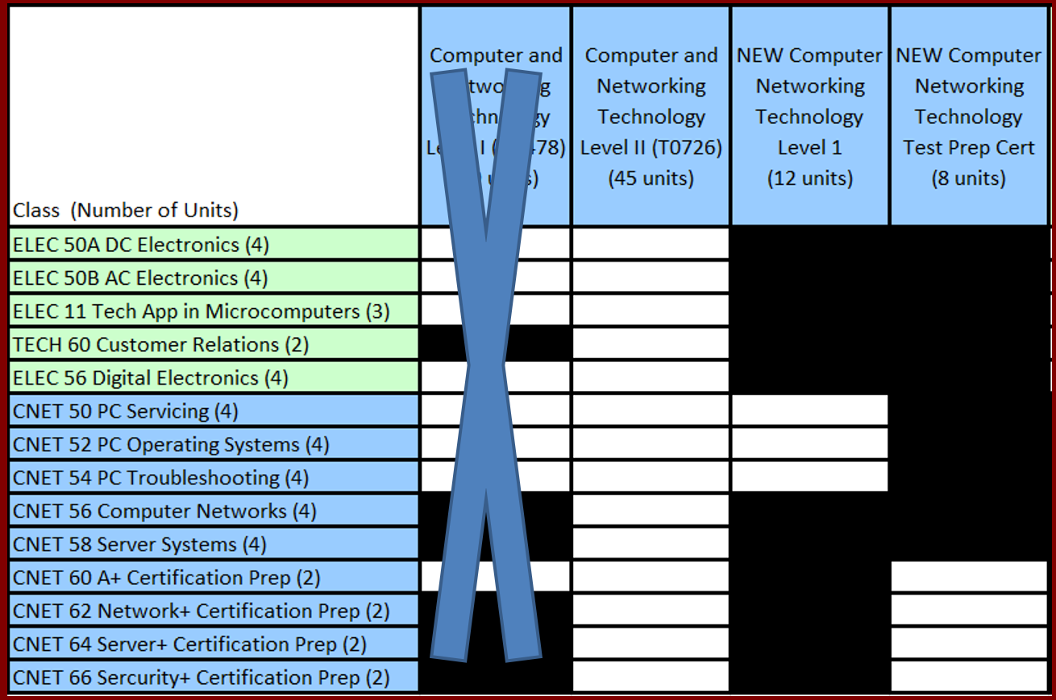  The new certificate names would be as follows:  Computer Networking Technology Fundamental  Computer Networking Technology Industry Certifications  Electronics Technology Level 1 Certificate  Electronics Technology Level 2 Certificate  A.S. degree in Electronics Engineering Technology  Equipment Purchases from Over the Previous Year:  No large instructional equipment was purchased this past year.  Invitation for employers to speak with groups students about their company and potential employment. Lunch and learn panels. We hosted presentations from Edison and Governor’s Office of Emergency Services this past year.  Invitation for employers to post to our alumni facebook group by emailing their request to jdenny1@mtsac.edu  Video wall resource is available to them. Mentioned to advisors that if there are any job openings that they would like to post to our video wall or our facebook group to let us know. |  |  | Advisors agreed having this degree would be not only useful in the industry sector for possible promotions and for transfer to 4 year schools.  Advisors felt knowledge was more important than the certificate types, so they were fine with whatever certificate they thought would benefit our students and program the most. This is because they give interviewees a knowledge test as part of their interview that they would have to pass. They are mostly concerned to have someone with actual rf experience that they can bring to the job. The degree is not required for entry level, but we also have senior positions that have to sit for an interview and coming in with a degree certainly have a leg up over somebody that doesn't  Pat would like to be contacted for possible career day events at our school so his company could be there.
Program Success Data |  | 2017-2018 | 2018-2019
 | Certificates  (From Pie Report) | CNET - 10  ELEC – 41 | CNET - 13  ELEC – 28
 | Degrees  (From Pie Report) | CNET – 9  ELEC - 12 | CNET – 11  ELEC - 11
Summary of Current and Projected Employment Outlook | LMI Data discussion.
Advisory Input | Intro Question  The following questions will be asked during introductions of the advisors:  - Are you hiring? Is your specific area of industry in a growth, decay or sustaining stage?  - Any new trends in your industry that we should know about?  - What is the value of an associate’s or bachelor’s degree in the industry? Should we be encouraging transfer more?  - How do you see the health or growth of our industry for the future?  The following specific questions will be posed to the advisors:  - Is knowing Lab View an essential skill to have?  2. Are data acquisition (DAQ) devices an important tool students should know? Is knowing how SCADA systems (Supervisory control and data acquisition) work important for your technicians?  3. How important is it for technicians to understand how to program microcontrollers, and understand programming languages? |  |  | Gerry – there has been a tremendous interest in new robotic product such as co-bots or collaborative robots. They are ideal for our programs. They don’t require a large amount of infrastructure, because they were designed to work around people which is great for students and safety. He invited Jim to go check out what Cal Poly has in models from Universal Robotics, and Fanic, ABB.  Labview is used in aerospace defense, medical device makers, and test environments, automotive manufacturing around electric vehicles such as amazon’s new vans.
Curriculum Review  4 year review & Modifications | Course Title  Would an Elective type cert be ok compared to what we currently have? See above  New A.S. Degree. See above. | 4 Year Review  Y/N | Modification  Y/N | No course content revisions are needed for courses this year.
Documentation of Program Needs | Equipment and Personnel requests:  - Student Lab Assistants  - Funding for new PLC’s for newly designed protoboards. Siemens or Allen Bradley  - A class set of power supplies  - IP Based KVM’s  - Benchtop DMM’s  - Labview?  - Data acquisition units (myDAQ)? |  |  | All who were in attendance voted in favor of these requests
Approval of this Year’s Minutes | To be sent out via email for approval
Tour of Facilities
Future Meetings | March 2021

